Result report

HW #4.1 result

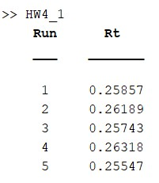

Mean Rt = 0.2593 與理論值 0.2600 相近

HW #4.2A result

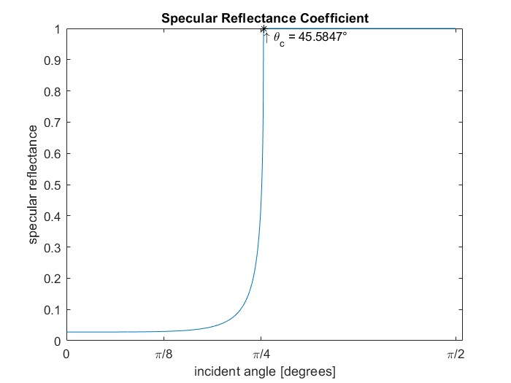

critical angle = 45.5847 degree

HW #4.2B result

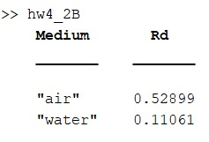

reflection coefficient of diffuse light

from tissue to air (n=1.0) = 0.52899

from tissue to water (n=1.33) = 0.11061